The implication of the Accelerationist hypothesis on Inflation
Name
Prof
Institution
Course
May 10, 2021

Economic growth in the United Kingdom has been on an upward trajectory. Measured in terms of real GDP per capita, the UK has consistently accumulated wealth and has achieved the world's highest living standards among the G-20 community. The resilience of her economy has been spectacular. According to classical economists, good institutions, the rule of law, and private property rights are fundamental for economic growth. Ostergard (2014) further suggests that private property rights and good institutions explain about 80% of GDP variations.
Nonetheless, The UK economy has been exposed to global macroeconomic shocks such as the oil crisis (1974), the Great Recession (2008), and the Covid 19 (2020) pandemic with severe ramifications for real output, Inflation, and unemployment rate. On average, the United Kingdom's unemployment rate has been on the increase throughout the 20th century. The high unemployment rate trend is not heavily concentrated in particular sectors of the economy (Blanchard & Portugal, 2001). Still, it is widely distributed in major industries and across all schooling groups, ages, and regions.
According to Tobin (1995), the inflation rate has a negative linear relationship with unemployment in the economy. As the level of Inflation rises, the unemployment level declines. The Philips curve shows a trade-off between the general price level increase and the unemployed labour force.
In his General Theory of Employment and Interest rates, John Maynard Keynes asserts that the economy lacks effective demand during a recession. A consensus is built to stimulate the aggregate demand in the economy; economists and policymakers must adopt expansionary fiscal and monetary policies. Growth in money supply in the economy is associated with increases in the general prices though it helps achieve desired aggregate demand. As investment and consumer spending rise in the short run, inventories are falling, and firms hire more workers
Fisher's (1933) quantity theory of money suggests that growth in money supply increases the aggregate demand in the economy. Supposing the economy was under full employment level, the movement along the short-run aggregate supply curve leads to higher real GDP. As the real output expands and aggregate demand rises at a higher rate, inventories are falling, and firms hire more workers to replenish inventories reducing the level of unemployment.
Irving Fischer, the founder of the monetarist school of thought, believed that Inflation is everywhere a monetary problem and that the government would attain a desired economic growth and employment level through adjusting the money stock in the economy. This school of thought focused on the short-run Phillips curve and assumed neutrality of money, in the long run, bringing serious economic divergence in policy stance, as shown in the graphs below.
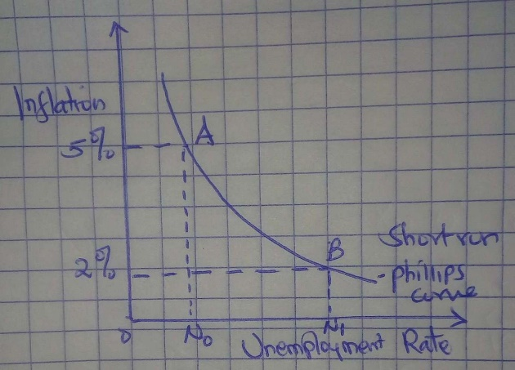
Short run long run
In the short run, the government can reduce unemployment in the economy by increasing the level of money stock through open market operations, reducing the reserve requirements, and decreasing the bank rates. Quantitative easing is meant to inject more liquidity into the economy so that at point A, the Inflation is at 5% and the level of unemployment is sustainably low at N_{o}.
However, in the long run, Inflation and unemployment are independent. As such, any attempt to increase the money supply in the economy results in an ultimate rise in the general price levels without a corresponding reduction in the level of unemployment in line with the accelerationist hypothesis, which states that the long-run effects of government attempt to reduce unemployment below the natural rate increases only Inflation.
Generally, an economy at a full level of employment experiences a low unemployment rate fundamentally arising from frictional and structural unemployment. Unemployment from the volatilities in the business cycle( cyclical unemployment) is equal to zero at the full employment level. When the actual GDP and potential GDP are equal, only a small proportion of the labour force is unemployed and economists believe that the natural rate of unemployment is inevitable. In other words, an economy would never achieve a full-employment level at any given moment.
Suppose that the economy is at full employment level, as shown in the diagram below
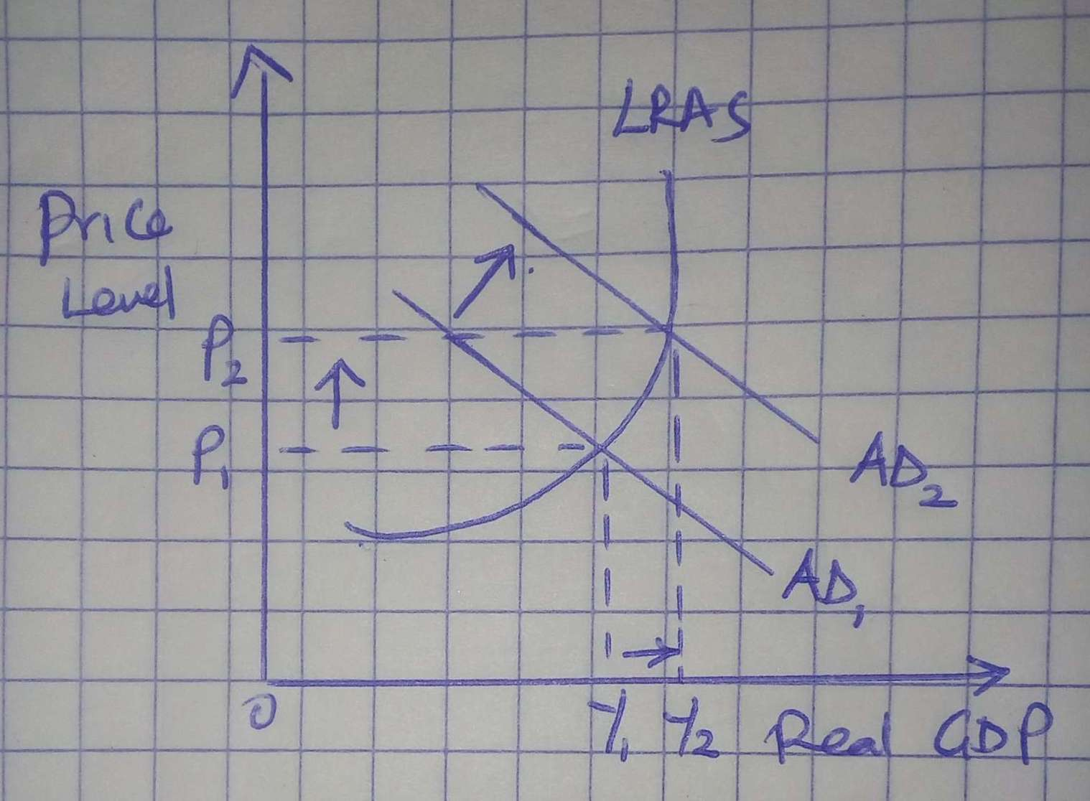
The shape of the long-run supply curve in the economy has economic implications that make the accelerated hypothesis hold. First, the slope of the LRAS is gentle in the beginning implying that a slight increase in the Aggregate demand results in a substantive increase in real GDP. The price levels are rising slowly because resources such as land and labour had not been utilized under production up to output level Y₁ at price P_{1.} Beyond this, the LRAS is very steep, so that an increase in the aggregate demand from AD₁ to AD₂ results in a very small increase in the real GDP. This is because most of the resources are underutilization and reallocating the resources is very expensive. At this point, the economy is at full employment with the lowest attainable level of unemployment.
The acceleration hypothesis holds beyond this level of full employment where it is futile for the government to attempt to increase Inflation to keep unemployment consistently below its natural rate. The LRAS is vertical at Solow's warranted growth rate, implying that stimulation of the aggregate demand would only lead to higher price levels with absolutely no increase in the real GDP.

References
Fisher, I. (1933). The debt-deflation theory of great depressions. Econometrica: Journal of the Econometric Society, 337-357
Keynes, J. M. (2018). The general theory of employment, interest, and money. Springer
Ostergard, R. L. (2014). Intellectual Property, Trade and Development, 3-40.
Tobin, J. (1995). Inflation and unemployment. In Essential Readings in Economics (pp. 232-254). Palgrave, London

